RESUME
Name: Jibanarayan Adhikari
Address: Bharatpur 9
Phone Number: 9855052935
Email: jivanadhikari02@gmail.com

Objective:
To work as an Animal Technician to improve animal health, husbandry, and productivity.

Educational Qualifications:
- Veterinary Junior Technical Assistant (JTA)
Institute: [Kantipur College of Medical Science]
Year: [2062]
- Secondary Education
School: [Jibanodhar secondary School]
Year: [2060]

Work Experience:
"15 years of experience as a Veterinary Technical Assistant (JTA), with expertise in animal health, nutrition, and husbandry."
- Knowledge of veterinary medicine
- Animal nutrition management.
- Vaccination and disease control.
- Laboratory testing and analysis.
- Breeding and production management.
- Animal husbandry consulting.

Certifications: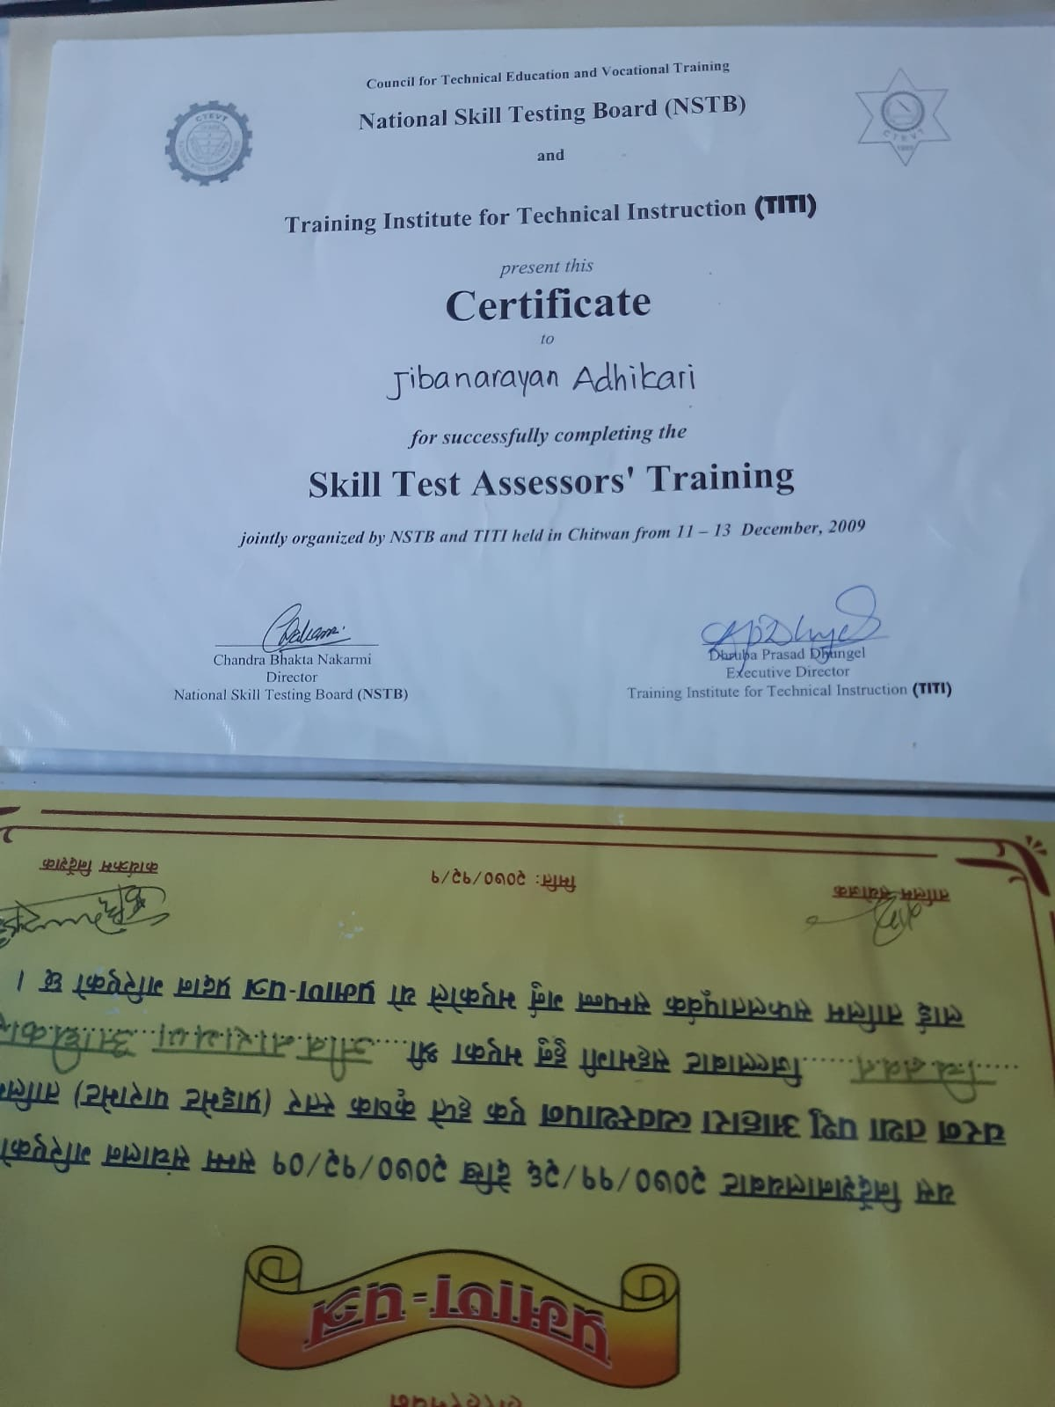
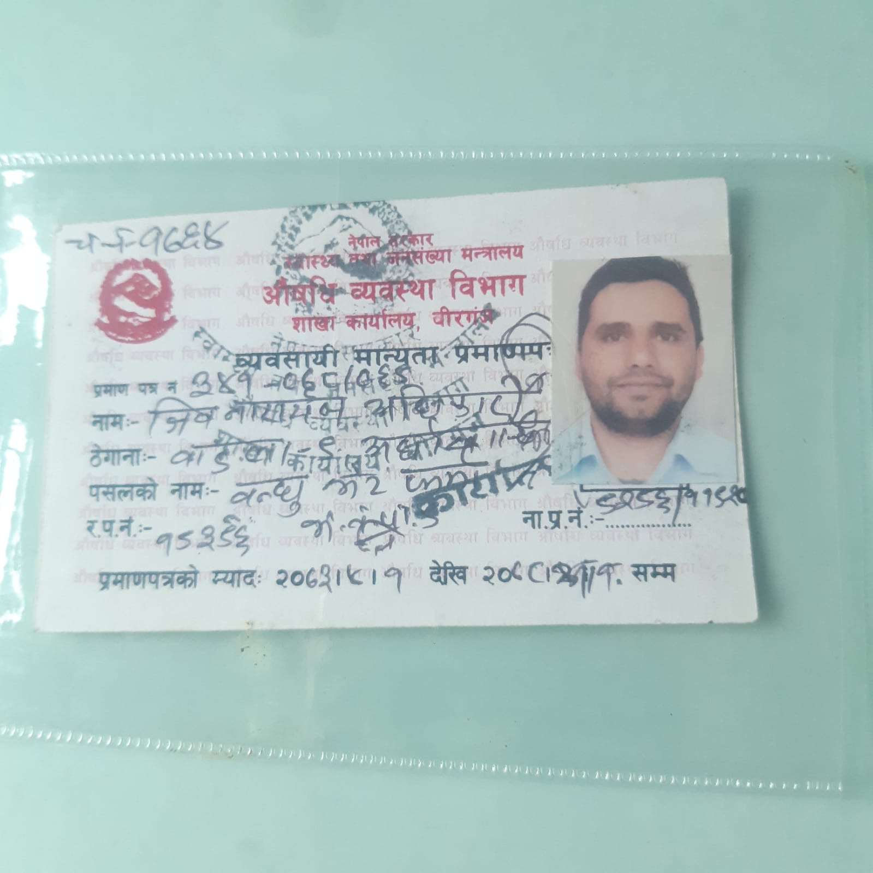

Language Skills:
- Nepali: Fluent
- English: Intermediate

Interests:
- Animal husbandry and farming
- Research and development
- Community service

